CRAG Recommended Fixed Anchor Hardware Standard for Route Maintenance at CRSP and CIRO.
- Overview
  - This spec is not intended for new route hardware and installations. In those cases, the CRSP CMP is the standard for both Castle Rocks and (until there is a new COR CMP) for City of Rocks.
  - Note: This spec meets or exceeds the current Access Fund Fixed Hardware best practices guidelines (https://www.accessfund.org/educate-yourself/for-advocates/managing-fixed-anchors/best-practices-for-bolt-placement).
  - Note: These specifications are consistent with the CRSP CMP but in some cases exceed the fixed hardware standards in that document.
  - Note: this document is predominantly a fixed hardware specification and does not try to be a manual for installation technique and/or capture all the variations of hardware installation requirements. Fixed anchor placement is complex. CRAG will interview and appoint only experienced people to ensure the hardware is installed properly. At a minimum, all hardware installations must meet the CRSP CMP requirements.
  - This spec is subject to change as Fixed Hardware standards are evolving. It is anticipated when a negotiated standard is adopted by the UIAA that this spec will be updated to the new standards.
- Bolt Materials
  - Required: Stainless Steel (SS) hardware (hangers and bolts), U.S. standard is 304 Stainless Steel. 305 or 316 Stainless Steel is also acceptable.
  - Required: Hangers must be commercially powder coated either by the OEM or after market. The powder coated hangers, bolt heads, washers, and top anchor components must be spray painted using good techniques to best match the surrounding rock.
- Stainless Steel Bolt Size
  - Required: Minimum of ½ inch (or 12mm) bolt hole diameter (sleeve bolts typically have bolt diameters of 3/8 in).
  - Required: Minimum of 2 ¾ inch bolt length (3 ½ inch or greater preferred).
- Preferred bolt is the sleeve style. Two manufacturers currently make this style of sleeve bolt in stainless steel.
  - SS Powers Power Bolt (5 piece sleeve bolt) ( ½ ” x 2 ¾ ” or longer) 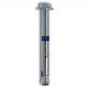
  - Fixe Triplex (12mm x 75mm – note 75mm ~= 2.9”) 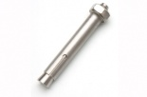

- Acceptable SS bolts include (if preferred bolt not available or not practical):
  - SS Stud or Wedge type bolt ( ½ ” x 3 ½” or longer) 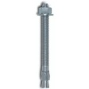
  - SS glue-in bolts (some placements in porous rock may require a glue in. This will be at the discretion of the experienced bolt installer).

- Stainless Steel Hanger Options
  - Preferred: The following companies make SS hangers with ½” or 12mm holes.
    - Fixe (bare metal or coated) – ½” or 12mm available. If bare is acquired it must be powder coated.
    - Petzl (bare metal only) – 12 mm available. Must be powder coated. Petzl also has hanger – bolt combo in 12mm stud bolts but Petzl doesn’t appear to sell the bolt standalone.
    - Notes:
      - There are other Euro brands that may be acceptable – follow requirements - SS, ½” or 12mm hole, powder coated, paired with a proper bolt, etc).
      - Mad Rock is 3/8” hole only so not acceptable.
      - ClimbTech (bare metal only) – 3/8” hole only so not acceptable as a stand alone hanger (Note: the Legacy Bolt-Hanger combo is designed to work with a 3/8” hole in the hanger).
      - Metolius (bare metal or coated) – but 3/8” hole only so not acceptable.
Fixe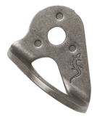 Petzl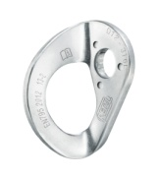 Petzl 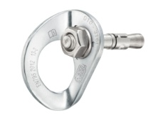ClimbTech 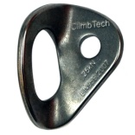Metolius 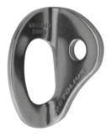
  - Note: Hangers should be compatible with bolt it is intended to be paired with. For example, by installation spec, a ½” diameter Powers Power-Bolt requires the hanger to have a ½” not 3/8” hole (even though it can be physically installed in this manner), or a 12mm triplex bolt must be paired with a hanger with a 12mm hole.

- Glue-in Bolt Options
  - Glue-in fixed anchors may be used for pro bolts or top anchors, so long as the rope will not travel through the glue-in.
  - Setter must have experience to properly place a glue-in. This is particularly tricky on vertical and overhanging placements.
  - Preferred: Must be commercial titanium anchors designed specifically for climbing, such as ClimbTech and Petzl products below.
.
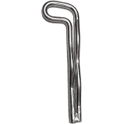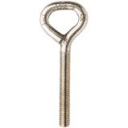
ClimbTech Petzl
  - Acceptable: Half inch threaded stainless-steel rod may be used as a glue-in when a longer length is needed than the climbing glue-ins above.
- Top Anchor Options
- Materials – Required: stainless steel hangers, chain, quick links and rappel rings.
- Preferred: Assembled Anchors
  - Top anchors shall consist of two separate SS hangers bolted to the rock with a minimum 1/2” X 3½” SS bolts. Attached to these shall be minimum 3/8” threaded SS screw links, with minimum SS 3/8” chains attached ending with a SS quick link and another SS single chain link or a SS welded rappel ring. The chain length shall be as short as possible without compromising safety or proper placement.
  - Required: all components must be spray painted to best match surrounding rock. Powder coating preferred.
  - Here is an example of an assembled top anchor. It consists of SS Hanger, SS Sleeve Bolt (1/2” x 4 ¾”), 3/8” SS quick link, 3/8” SS Chain Links, 3/8” SS Quick Link, and a single ½” SS chain link for the rope pull. Note: all components are spray painted and chain links were spray painted with a rust colored primer.
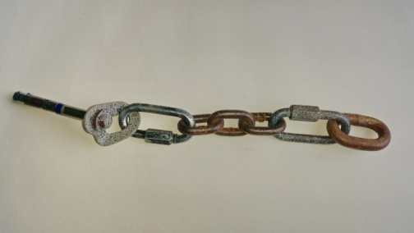

- Acceptable: Commercial Anchors and Anchor Sets

  - Top anchors shall consist of two separate SS hangers bolted to the rock with a minimum 1/2” X 3½” SS bolts. Attached to these shall be minimum SS 5/16” threaded screw links, with minimum SS 5/16” chains attached, and welded SS ring(s) for the rope pull.
  - Required: all components must be spray painted to best match surrounding rock. Powder coating preferred.
  - Fixe Hardware has several styles that meet this standard
    - Fixe SS Double Ring Anchor 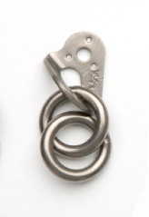
    - Fixe SS Traditional Anchor 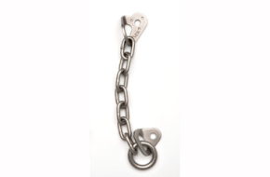
    - Fixe or ClimbTech SS Chain Anchor 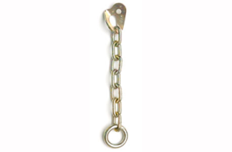

  - A commercial anchor set up would be one Fixe SS Traditional Anchor, or two Fixe SS Double Ring Anchors, or two Fixe SS Chain Anchor, or one Fixe SS Double Ring Anchor + one Fixe SS Chain Anchor.

- Acceptable: Hooked Top Anchors
  - Hooks can only be placed on vertical to overhanging rock, for top anchors only. On lower-angle rock an accidental unclip can occur if the climber moves above the anchors. Low-angle dome-tops are common in CIRO & CRSP.
  - Hooks should be hardened steel, with a sturdy spring gate, such as ClimbTech Top Anchor Hooks:
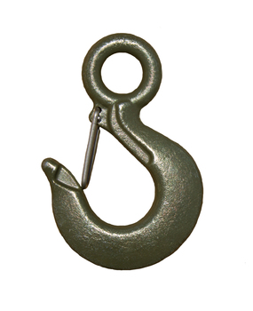
  - Construction-style mussy hooks and shuts are not acceptable, such as these.

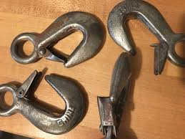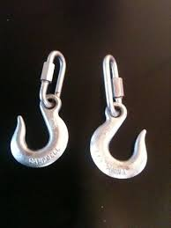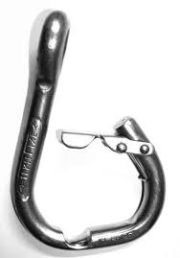

- Hooks must be easily replaceable in the field when they show wear, via the attachment system to the rock such as quicklinks.

- All other hardware used in the hook anchor including the bolts, hangers, quicklinks and chain, must meet specifications for CRAG hardware for bolt replacement (including paint for camouflage).

- Glue-in fixed anchors may be used for hook anchors, since the rope will not travel through the glue-in.

- The spacing between the two bolts or glue-ins must meet the manufacturer’s spec (typically 10X the bolt hole diameter, so at least 5” apart). Quality of rock must be judged by the bolt-setter: softer, patinaed, fractured or granular rock will indicate wider placement of the 2 bolts.

- If hooks are connected directly to hangers by only one quicklink, the angle between hooks when loaded should not be more than 45 degrees. Hooks should be placed to equalize load and wear-and-tear as much as possible. With a wider bolt spacing the hooks may need to be attached with SS chain for more length.

e. Additional Top Anchor considerations:
  - All top anchor components must be painted to best match the surrounding rock.
  - Avoid sharing top anchors when possible. No more than two routes can use a single top anchor.
  - Top anchor should be placed in appropriate location with safety, as well as rope retrieval considered.
  - Top anchor bolts shall be spaced no closer than 5 inches apart (or further if the longer 4 ¾” Power Bolt is used).
  - Top anchors should not be set back from the edge if possible

